Mill Woods United Church
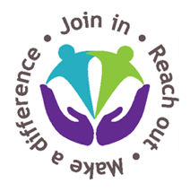
For new enrollment or for changes to
Pre-Authorized Remittance (PAR) or credit card
(Changes can be made at any time by contacting the church office 780-463-2202 or mwuc1@telus.net)

[ ] To start PAR: Please start me in the PAR program and withdraw $______________ per month from my account on or about the 20th of each month. Attach a VOID cheque to this form or provide bank information below.

Bank name and address: (numbers from the bottom of cheque)

__________________________________ _________ __________ ______________________

__________________________________ Branch Institution Account Number

[ ] To change PAR: Please change my monthly amount to $_____________________

[ ] To begin/change credit card: Please charge $______________________ per month to my credit card.

CREDIT CARD: [ ] Mastercard [ ] Visa

Card Number: ______________________________________ Exp. _____/_____

Cardholder Name:__________________________________________________

Authorized Signature:

Signature:_____________________________ Date:___________________________________

Thank you for your financial support to Mill Woods United Church!

